Agile Business Analysis

*BA Design Folio*

Project: *La***◈***Viña*

*Client not Specified*

*Author:* Yasin Çakar

*S Number:* 2921450

*Workshop:* Wednesdy, 12:00-13:50, Dr Leigh Ellen Potter

*Table of Contents*

1 Introduction 1

2 Customer Focus 1

2.1 Target Audience 1

2.2 Client Organisation 7

3 Product Vision 12

4 Stories 15

4.1 Requirements 15

4.2 Story Map 24

4.3 Releasable Product 25

5 Team 25

6 Review 32

# Introduction

*Give a brief statement outlining what this document is and what you aim to provide in this document. List the tools that you have used to develop your work.*

The La◆Viña app is a smartphone application, that is also accessible online without downloading the mobile itself, the system allows users to view the different types of wines from the client organizations winery via their website or in the web page or interactively in an animated cellar that represents a virtual retail cellar. The La◆Viña virtual cellar can be accessed via a web browser or the application.

La Viña in Spanish means “*the vineyard*”. The application is designed to provide convenient browsing for customers interested in purchasing wine, as though they are in a cellar in a vineyard. The application is designed for all potential customers interested in wines from the naïvest in wine to the wine enthusiast. The La◆Viña system provides easy access to information about wine using its realistic cellar animation that can be explored with basic swipe gestures used in todays smartphone and tablet platforms.

The application will not only provide convenience to wine connoisseurs but also assist all customers in learning about wine as well as ordering what they see in a few taps and swipes gestures.

The La◆Viña system will also provide registered customers with their personal virtual cellar, called *myCellar*, to track their orders and set the frequency of their orders.

This document will provide the basis for developing this product, covering the benefits for the end user, being the customer, the benefits for the client organization, the product vision, product requirements, the team process of the development team for this product, followed by the review that summarizes the lessons learned for the duration of studying agile business analysis.

# Customer Focus

*Agile places the client and customer at the centre of the project. Who are your clients and who are your customers for this project? What are their needs?*

*Apply an Agile tool to support your definition of your customers.*

This section covers the client of the development team as well as the end user who is the client of the project owner.

## Target Audience

The target audience for the proposed product is all wine consumers regardless of their level of interest in wine. The reason this is possible is due to the hard work of the development team to deliver such a design to simplify the interaction between the user and the La◆Viña system, the design is aimed at supporting customers to conveniently browse through wine selections based on their preferences or any combination of the preferences for wine characteristics including:

* Wine type (red, white, rose etc.)
* Flavor profile
* Tannin
* Age
* Food pairing options (wine matcher option for dish type)
* Price
* Vegan selection
* Packages (eg Taster sets, variety cases)
* Region (at later stages of La◆Viña, see 2.2 Client organization)

Customers will be able to enter the virtual cellar via the website or the mobile application. Using this design implementation, connoisseurs can find their particular product using simple gestures from their touch pads. The benefits to this design feature is that the general customer can make an optimal selection by arranging the virtual cellar planogram layout to fit their price range, and other search criteria, such as the ones listed above, in their search filters, this implementation keeps the end user engaged as they will not need to click through pages. This design feature is equally beneficial to the naïve user as they can learn more about wine and perhaps find new products to add to their cellar.

Another differentiating feature of this product is the myCellar feature, this is the virtual cellar of the customer that visually shows their purchases as a virtual animation, it visually illustrates the status of their own personal cellar. The virtual cellar visually shows the contents of the customers’ cellar in real life. When the customer has browsed for a product or their particular product, they drag the item from the makers’ cellar and drop into their personal cellar, the customer simply swipes a slider at the bottom of their smartphone vertically to place the order, the purchased bottles are shown in their myCellar as shaded, after the their product arrives to their door the same items are animated in full color and receive an animated notification. When the customer consumes a bottle of wine they drag and drop the bottle from their virtual cellar, if the customer does have an ordering plan such as “If the number of sauvignon blanc bottles fall below eight, reorder fto replenish my stock to 20 bottles”.

Several questioners and interviews were conducted since the handing of this assessment item, findings were noted and grouped to develop a persona that fits best with the cluster of data in the evenly distributed sample space of the interview and questionnaire trials.

Based on the research activity the trials found that this product can potentially benefits all customer bases from the least interested, to the wine enthusiasts, the persona to represent the target audience is shown in figure 1.

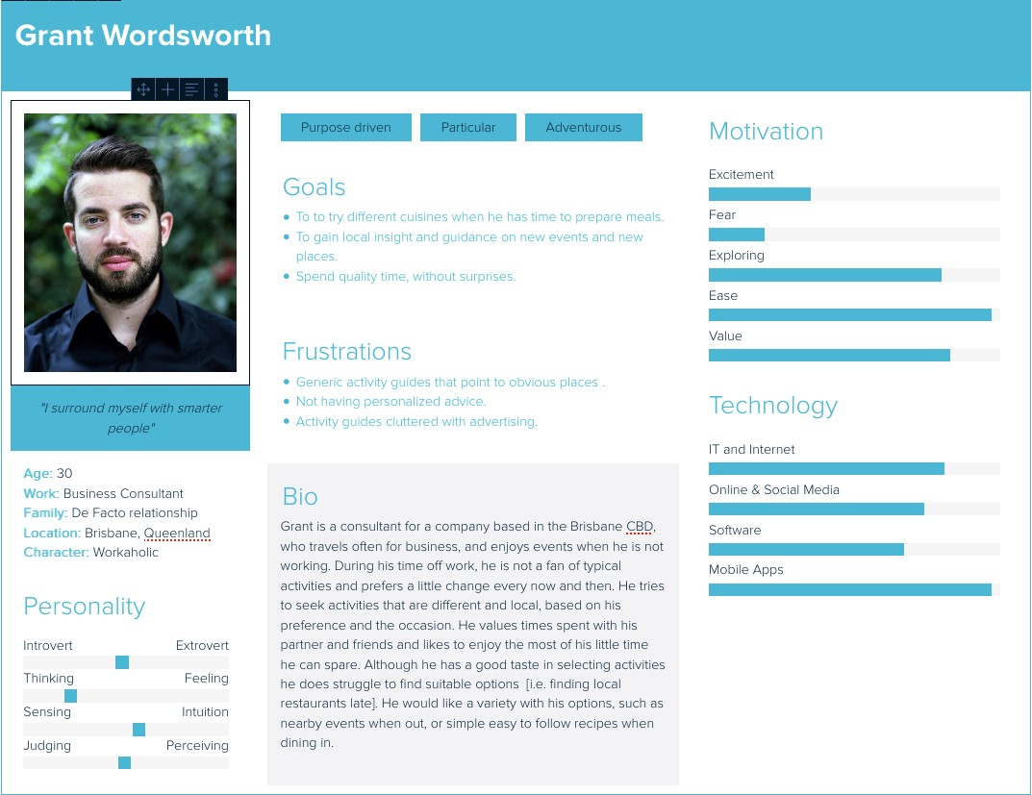

**Figure 1 Persona to represent target audience**

Customers who are members of La◆Viña can also sign up to the Vino◆Club using the mobile app. Vino◆Club is an online community that bring wine lovers (and newbies) together . Often people who are new to cellaring need advice on how to age specific wines, the Vino◆Club allows wine lovers to connect and share their experiences and provide advice, this members only club also allows users to follow the tasting panel members and other wine experts.

Aging wine is not as simple as determining a *best to consume* date from when it was produced as shown below in figure 2

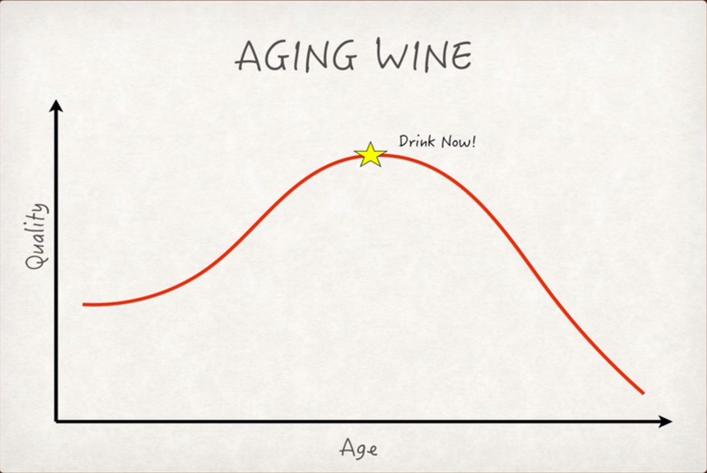

**Figure 2 Predicting the wine maturity is not as simple waiting for time to elapse**

Wine quality with aging cannot be thought of as a single factor that progresses along a steady line of maturation until the quality hits a single peak from where the remaining progression of quality to be downhill is too simplistic and not the case in reality.

When a tasting panel evaluates wine for the judgment of its quality, there a number of factors that define the quality such as flavor, tannin and acid profiles as well as a number of other components which forms a dynamic system where each component parts develops at its own rate. This perspective of wine quality bring the idea that can be thought of as a *window of opportunity* that determines the best time to consume wine, this idea represents a slice of this dynamic system, in this system where most of the developing characteristics are in strong places in terms of quality, this *drink window* also shows how the characteristics are integrated together in the flavor profile, this concept is shown in figure 3 below.

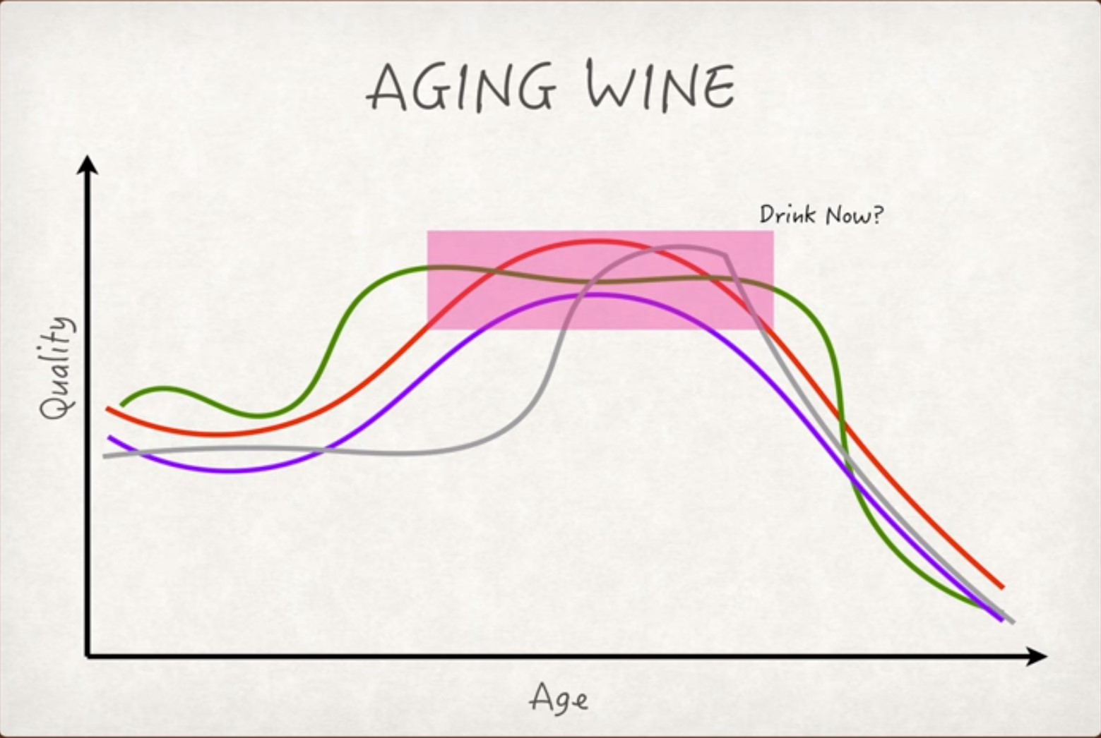

**Figure 3 Wine maturity is a complex system of numerous elements**

Vino◆Club members can connect with other wine customers to share their experiences and seek advice based on others’ cellaring experience. For example a customer purchases a wine that he/she would like to age in a cellar but is not sure when the ideal *drink window* is, he/she can connect with others on Vino◆Club to seek their advice, or cellar together with the online community.

In the two storyboard scenarios below there are two actors Grant and Michelle. The two storyboards capture the functionality of the proposed La◆Viña design; they describe the steps each end user takes to complete their purchase. Grant is a wine enthusiast much like a connoisseur who is willing to pay for a premium product, Michelle on the other hand knows a little about wine but soon learns more than she expected about wine due to the animated and interactive virtual cellar and the gesture based interface she is used to using, making it easy to use and intuitive. Grant is using the web version on a personal computer while Michelle uses the La◆Viña application on her iPhone.

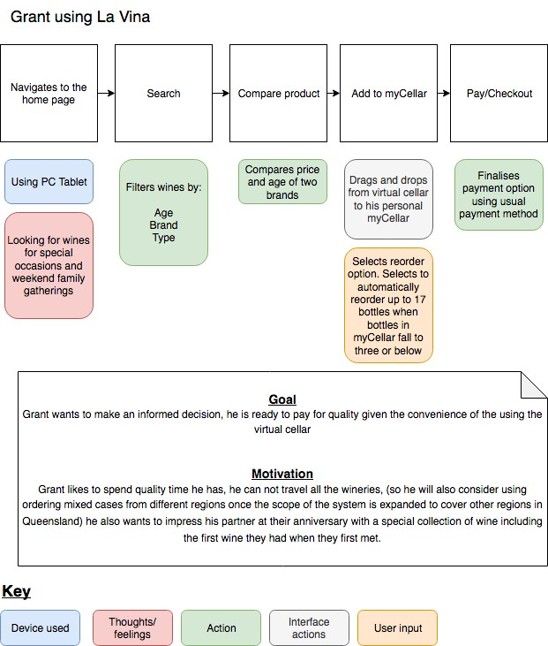

**Figure 4 Storyboard capturing Grant's user experience with La**◆**Viña**

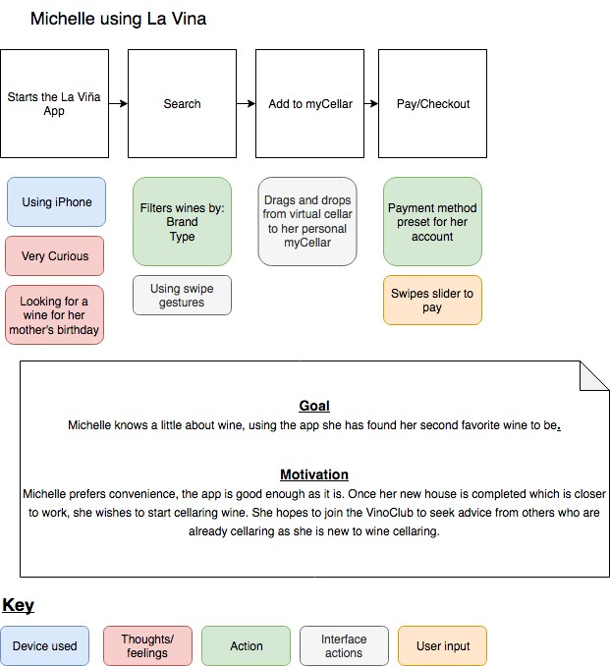

**Figure 5 Storyboard capturing Michelle's user experience with La**◆**Viña**

## Client Organisation

The client that this project is intended for is a company that sources and sells wine from a specific Australian wine region to their clients. This document will make the assumption that the client is a winery or a company that works exclusively with a winery.

The La◆Viña system will be delivered in four releases, the first will be a basic website with a browsing and search functionality as well as a checkout like any other online website that sells products online. The second release will have the company’s virtual cellar and the client’s personal virtual cellar in a cascaded style sheets animation. The second release will improve the user experience from the first release. The main release will be the fourth release, this will be the most costly version with high quality image rendering for a three dimensional animation of the virtual cellar.

Each product release will generate a revenue stream to fund the next release. The basis of this assumption is based on the following trade-off matrix.

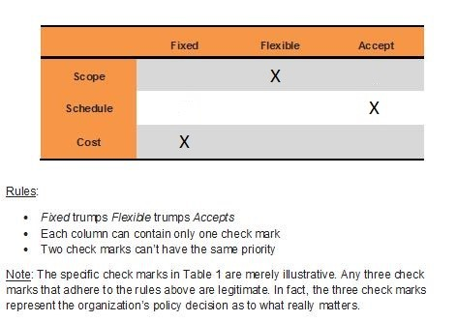

**Figure 6 The Trade-off matrix illustrating the reason behind bussiness decisions**

**in developing La**◆**Viña**

The scope is identified as Flexible as each iteration will add new functionality to La◆Viña. The final release will be called La◆Viña. The scope is flexible in terms of delivery of functionalities in each release, however fixed in terms of the long term strategy horizons that define the reasons for the release of the final product in four stages. This strategy horizon can be defined in two ways, in this document they are referred to as Strategy One and Strategy Two (see table 1). Scope is only set to flexible to accommodate all necessary functionality defined in the section 4 over the duration of the four releases.

The Schedule has been identified as accept. In the world of business time is a valuable commodity, the schedule has been identified as accept as revenue from wine sales takes time due to the nature of the product. The time allowed until the revenue from previous iterations can successfully fund the development of the innovative ideas that will make La◆Viña the most convenient means of purchasing wine.

Cost of the project has been identified as fixed as each iteration should support the budget of the next iteration.

**Table 1 The two possible ways of defining the possible strategies for La**◆**Viña**

|  |  |  |  |  |
| --- | --- | --- | --- | --- |
| Strategy One | | | Strategy Two | |
| Release:            1 | Strategy  To increase wine sales of the client company to a broader range of customers to increase sales. | OR | | Strategy    To increase revenue steams from the wine industry by introducing an ordering concept and maturing it to become the next *new uber* maturing.    The client organisation may provide this platform as a service to other winery regions to list their own products. |
| Initiative  Provide an online platform that makes ordering wine convenient |
| Delivery  Develop a web based online ordering system. | Initiative    To provide an online platform that provides services with basic the basic requirements (see figure 10) and develop the system’s capability with revenue generated by previous iterations. |
| Releases:              2,3 and 4 | Strategy  To provide wine ordering service on an accessible platform that is convenient and easy to use. |
| Initiative  To provide an online platform with an interactive virtual interface suitable to all client over 18 years old. | Delivery    Develop and deliver the La◆Viña system through continual iterations (towards release 4) until the product satisfies the purpose alignment model in figure 7 |
| Delivery  Enhance the La◆Viña system with greater interaction capability and an high quality rendering of a virtual cellar. |

The release of this product is expected to be a success due to the simplicity of the user interface with the system’s complex functionality. The only requirement for this application will be basic computer literacy as it will be available on two common platforms, they are the web and the app stores for smartphones. The La◆Viña system will also be accessible without the app, with only the clients’ online account. This new interactive design will provide better results than the present services for ordering wine as it requires the same technical understanding that the common end user has.

The virtual cellar feature provides convenience to all consumers, from general customers to wine lovers as well as people who want to learn more about wines. This elaborate design by the development team coupled with the simplicity of the interface will potentially attract more customers through the convenience and information offered about wine.

The need for this product is due to the fact that the convenience this product provides (see vision in table 2) through the product releases (see story map in figure 10) will create a niche in the market that will support customer convenience and meet the client’s business goals. This is illustrated in the diagram below.

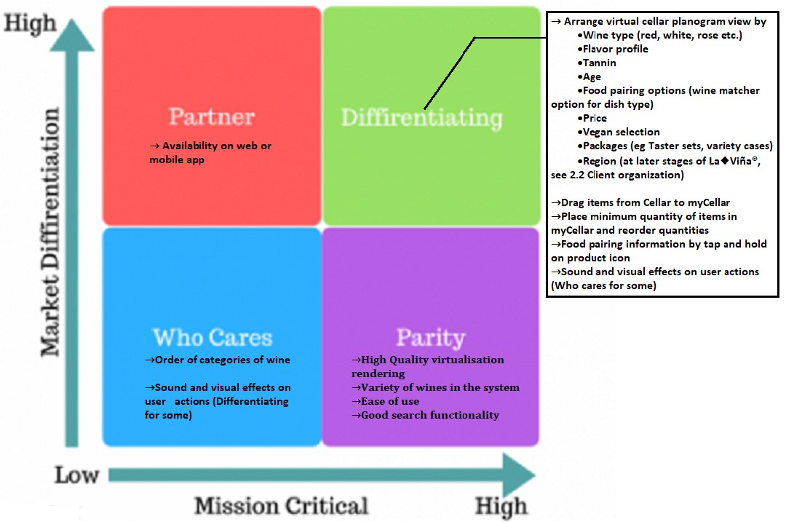

**Figure 7 The business need for La**◆**Viña**

This competitive advantage is necessary for the client, as there already is a market for sales of wine on the web platform. Many of these competitors also host events and showcase their products in select festivals. The maturation of this product into its fourth release will allow the client to provide La◆Viña’s services to other wineries that would like to increase their sales.

This application will create revenue streams through sales, allowing other wine makers to list their products as well as online advertisements on the site, that is the case for members who do not upgrade their membership to remove advertising.

The La◆Viña app will assist customers in tracking their cellars through the *myCellar* feature, this is an important feature as some customers will have cellars that hold 20 bottles to customers with walk in cellars that hold up to 4000 bottles. Customers can also adjust the frequency of their orders based on periodic ordering or based on stock count in their personal cellars.

This benefit also extends to the client of this project, the project owner who is also a wine seller. The client can use this system’s order logs utilize the data mining features to manage their own stock as the supplier.

The proposed method for the client to manage its stock count is with the live count of La◆Viña’s database with each transaction. Assuming the company has an undisclosed amount of cellars for each wine type with the cellar organized into isles. The proposed method for the clients stock take is to keep a live count of the number of wine bottles in each cellar rack (say 4000 bottles in a rack), assuming the number of racks for each isle is twelve, and each cellar room will have a particular number of isles. This method of stock count will happen in real time as the database creates a unique identifier to represent each bottle in the cellar, this unique identifier also corresponds to the number of bottles for that type and brand of wine, this concept is illustrated below in figure 8. Every time a new bottle is added to the cellar from the vineyard the database automatically updates the unique identifiers.

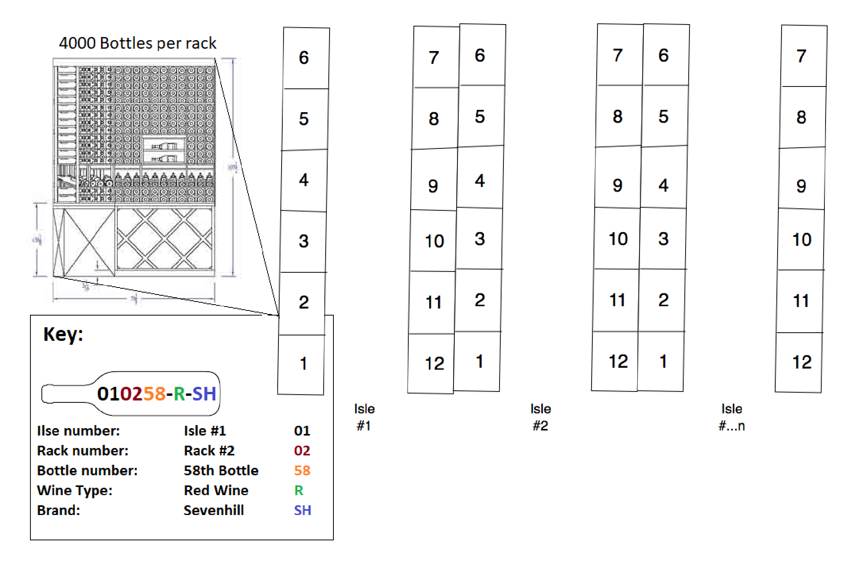

**Figure 8 Proposed method of managing stock in the cellars**

# Product Vision

*Visioning is a critical process for Agile projects. Complete a visioning activity (apply a visioning tool) for this project, and present a clear Vision that will support the rest of your work in this document, and help your team achieve a shared focus.*

The product vision is a concise convincing statement that outlines the desired outcome. This statement summarizes the reason to develop the product qualities mentioned in section 4.

The product vision states the “*why”* to the development of this product, the next section will discuss the how.

The vision statement below promotes a focus to why this product is relevant to the end user of this product.

**Table 2 The Vision statement outlining the purpose of developing La**◆**Viña**

|  |  |
| --- | --- |
| **FOR** | Wine customers and wine lovers |
| **WHO** | Look for a selection of wines (including a variety of wineries and wine makers in later releases) |
| **THE** | La◆Viña system |
| **IS A** | Web based wine retail site |
| **THAT** | Allows customers to conveniently browse and purchase wines |
| **UNLIKE** | Mainstream wine retail sites |
| **OUR PRODUCT** | Offers an immersive and interactive experience with only basic computer literacy required to make an informed decision, by learning the range of options available. |

The vision for the product owner is however more complex as the client organization need sufficient business justification.

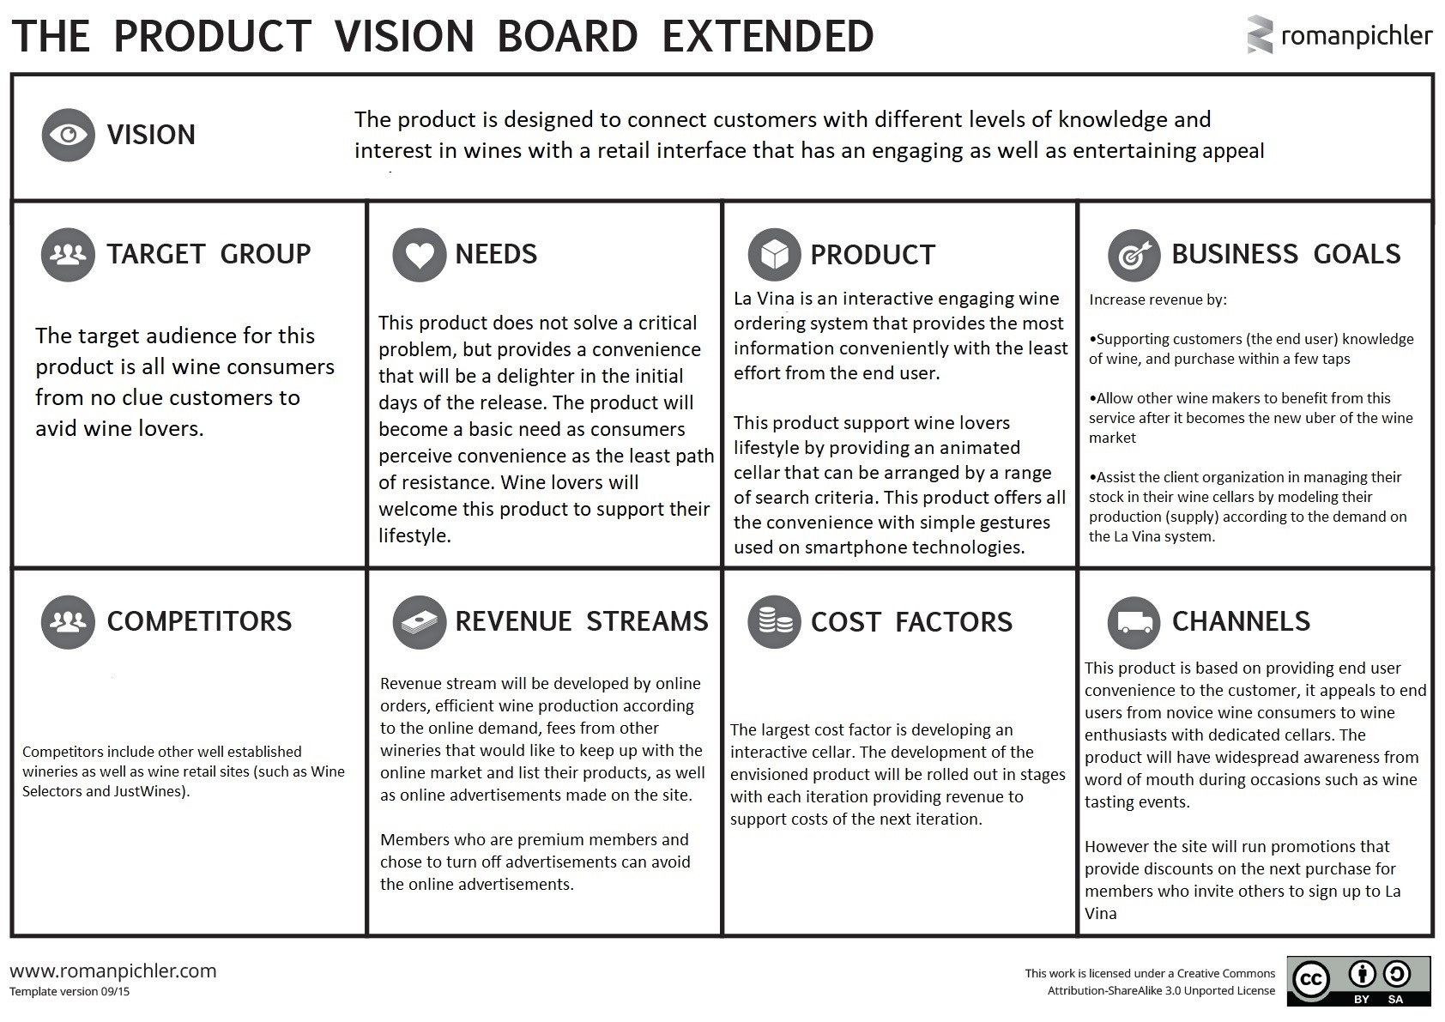

**Figure 9 The extended Product Vision for the client organisation**

# Stories

*Product requirements are captured in stories for Agile. Provide a detailed, defined, prioritised list of Agile stories supported by an Agile tool. This could be a backlog, story decomposition, story mapping, or other product or requirements tool.*

This folio has focused on the key attributes of the proposed finished product, the benefits to the end user and client organization as well the vision to keep the development team and other stakeholders focus and motivation until the close of the project.

Below is a product backlog of the La◆Viña system with a list of all requirements to support an initial project effort. These requirements were brainstormed on loose notes, requirements that were in the epics written in prose were later broken down into their composite user stories, these user stories are high-level list of features.

The stories in the backlog of section 4.1 are then to be processed as sprintable stories. The epics have been broken down into stories in section 4.1, these stories have been prioritized into a story map in section 4.2

## Requirements

The requirements listed for the La◆Viña app has been defined after brainstorming with a small sample space of participants (that may not necessarily represent a fair reflection of the entire population of wine consumers). These requirements were decomposed using story decomposition after the initial brainstorming.

**Table 3 Product Backlog of user stories**

|  |  |  |  |
| --- | --- | --- | --- |
| **Registered User Stories** **Business user stories** **Subscribed user stories** | | |  |
| **As a:**  (Registered) user **I want to:**  Be able to access the site from any device (mobile, tablet or computer) **So I can:**  have the convenience of choosing and managing my wine consumption | **As a:** business **I want to:**  have a system that will be able to  give recommendation to customers base of previous consumption  **So I can:**  better manage inventory and cashflow | **As a:**  Subscribed user **I want to:**  have my virtual own cellar **So I can:**  plan my wine consumption and ensure availability for special occasions | **As a:**  Visitor to the site **I want to:**  be able purchase without registration **So I can:**  make quick purchases |
|
|
|
|
| **As a:**  registered user **I want to:**  browse the online store **So I can:**  make purchases | **As a:** business **I want to:**  have a platform for my online presence that is fun, playful and engaging **So I can:**  help retain customers and atract new ones | **As a:**  subscribed user **I want to:**  be able place an order for a product in my virtual cellar **So I can:**  consume my favourite wines | **As a:**  Visitor to the site **I want to:**  be able to register **So I can:**  make secure purchases |
|
|
|
|
| **As a:**  registered user **I want to:**  browse by categories **So I can:** | **As a:** business **I want to:**  be able identify products for optimum specials time |  |  |
|
|
|

|  |  |  |  |
| --- | --- | --- | --- |
| discover other wine types | **So I can:**  ensure the wines are sold before the wines are outside the optimum consumption window |  |  |
|
| **As a:**  registered user **I want to:**  be able to place an order from the available stock **So I can:**  consume my favourite wine | **As a:** business  **I want to:**  give registered users a “virtual cellar” service **So I can:**  generate new streams of revenue |  |  |
|
|
|
| **As a:**  registered user **I want to:**  be able search **So I can:**  find a particular brand, type, food pairing age or cost of wine |  |  |  |
|
|
|
| **As a:**  Registered user **I want to:**  be able to read details of products **So I can:**  make a decision on my purchases |  |  |  |
|
|
|
| **As a:** |  |  |  |
|

|  |  |  |  |
| --- | --- | --- | --- |
| Registered user **I want to:**  be able sign in with an email **So I can:**  Access my account with email address |  |  |  |
|
|
| **As a:**  registered user **I want to:**  be able to select an automated replenishment order for my regular consumption **So I can:**  always have wine at hand and be able to have wine with guests, friends and loves ones |  |  |  |
|
|
|
| **As a:**  registered user **I want to:**  be able sign in with instagram **So I can:**  access my account with instagram |  |  |  |
|
|
|
| **As a:**  Registered user |  |  |  |
|

|  |  |  |  |
| --- | --- | --- | --- |
| **I want to:**  be able to sign in with Facebook **So I can:**  Access my account with  Facebook |  |  |  |
|
|
| **As a:**  registered user **I want to:**  be able share my purchases on twitter  **So I can:**  share my favourite wines with my friends on twitter |  |  |  |
|
|
|
| **As a:**  registered user **I want to:**  be able to save and manage multiple delivery addresses **So I can:**  easily send great wines to my friends and loved ones |  |  |  |
|
|
|
| **As a:**  registered user **I want to:**  be able to pay with a creditcard |  |  |  |
|
|

|  |  |  |  |
| --- | --- | --- | --- |
| **So I can:**  easily pay for my order |  |  |  |
|
| **As a:**  registered user **I want to:**  be able to pay using different methods **So I can:**  have the convenience of paying with the easiest method for that point in time |  |  |  |
|
|
|
| **As a:**  Registered user **I want to:**  to be able to receive  recommendations for new types of wines that I might find enjoyable based on my previous preferences **So I can:**  have a more enjoyable product experience as well as discover and enjoy a varied range of wines |  |  |  |
|
|
|
| **As a:**  Registered user **I want to:** |  |  |  |
|
|

|  |  |  |  |
| --- | --- | --- | --- |
| use an advanced search **So I can:**  easily pinpoint a particular product I am chasing |  |  |  |
|
| **As a:**  Registered user **I want to:**  be able to interact with other wine enthusiasts **So I can:**  exchange ideas about the many different types of wines and different ways of consuming wines |  |  |  |
|
|
|
| **As a:**  Registered user **I want to:**  be able to maintain a favourites list  **So I can:**  easily enjoy a favourite wine that I only occasionally consume |  |  |  |
|
|
|
| **As a:**  Registered user **I want to:**  Join VinoClub |  |  |  |
|
|

|  |  |  |  |
| --- | --- | --- | --- |
| **So I can:**  See the ideal drink window  (tannin, flavour profile, acidity) for a wine I am about to age. |  |  |  |
|
|  |  |  |  |
|  |  |  |  |
|  |  |  |  |
|  |  |  |  |
|  |  |  |  |
|  |  |  |  |
|  |  |  |  |
|  |  |  |  |

## Story Map

The benefit of story mapping is to convey the workflow between user stories. The story map is designed support the design concept of the storyboard in figure 4 and figure 5 above, as a product backlog makes it difficult to recognize any gaps between requirements, this means without storyboarding or story mapping the business context is lost.

The story map below assists in viewing requirements from a user point of view.

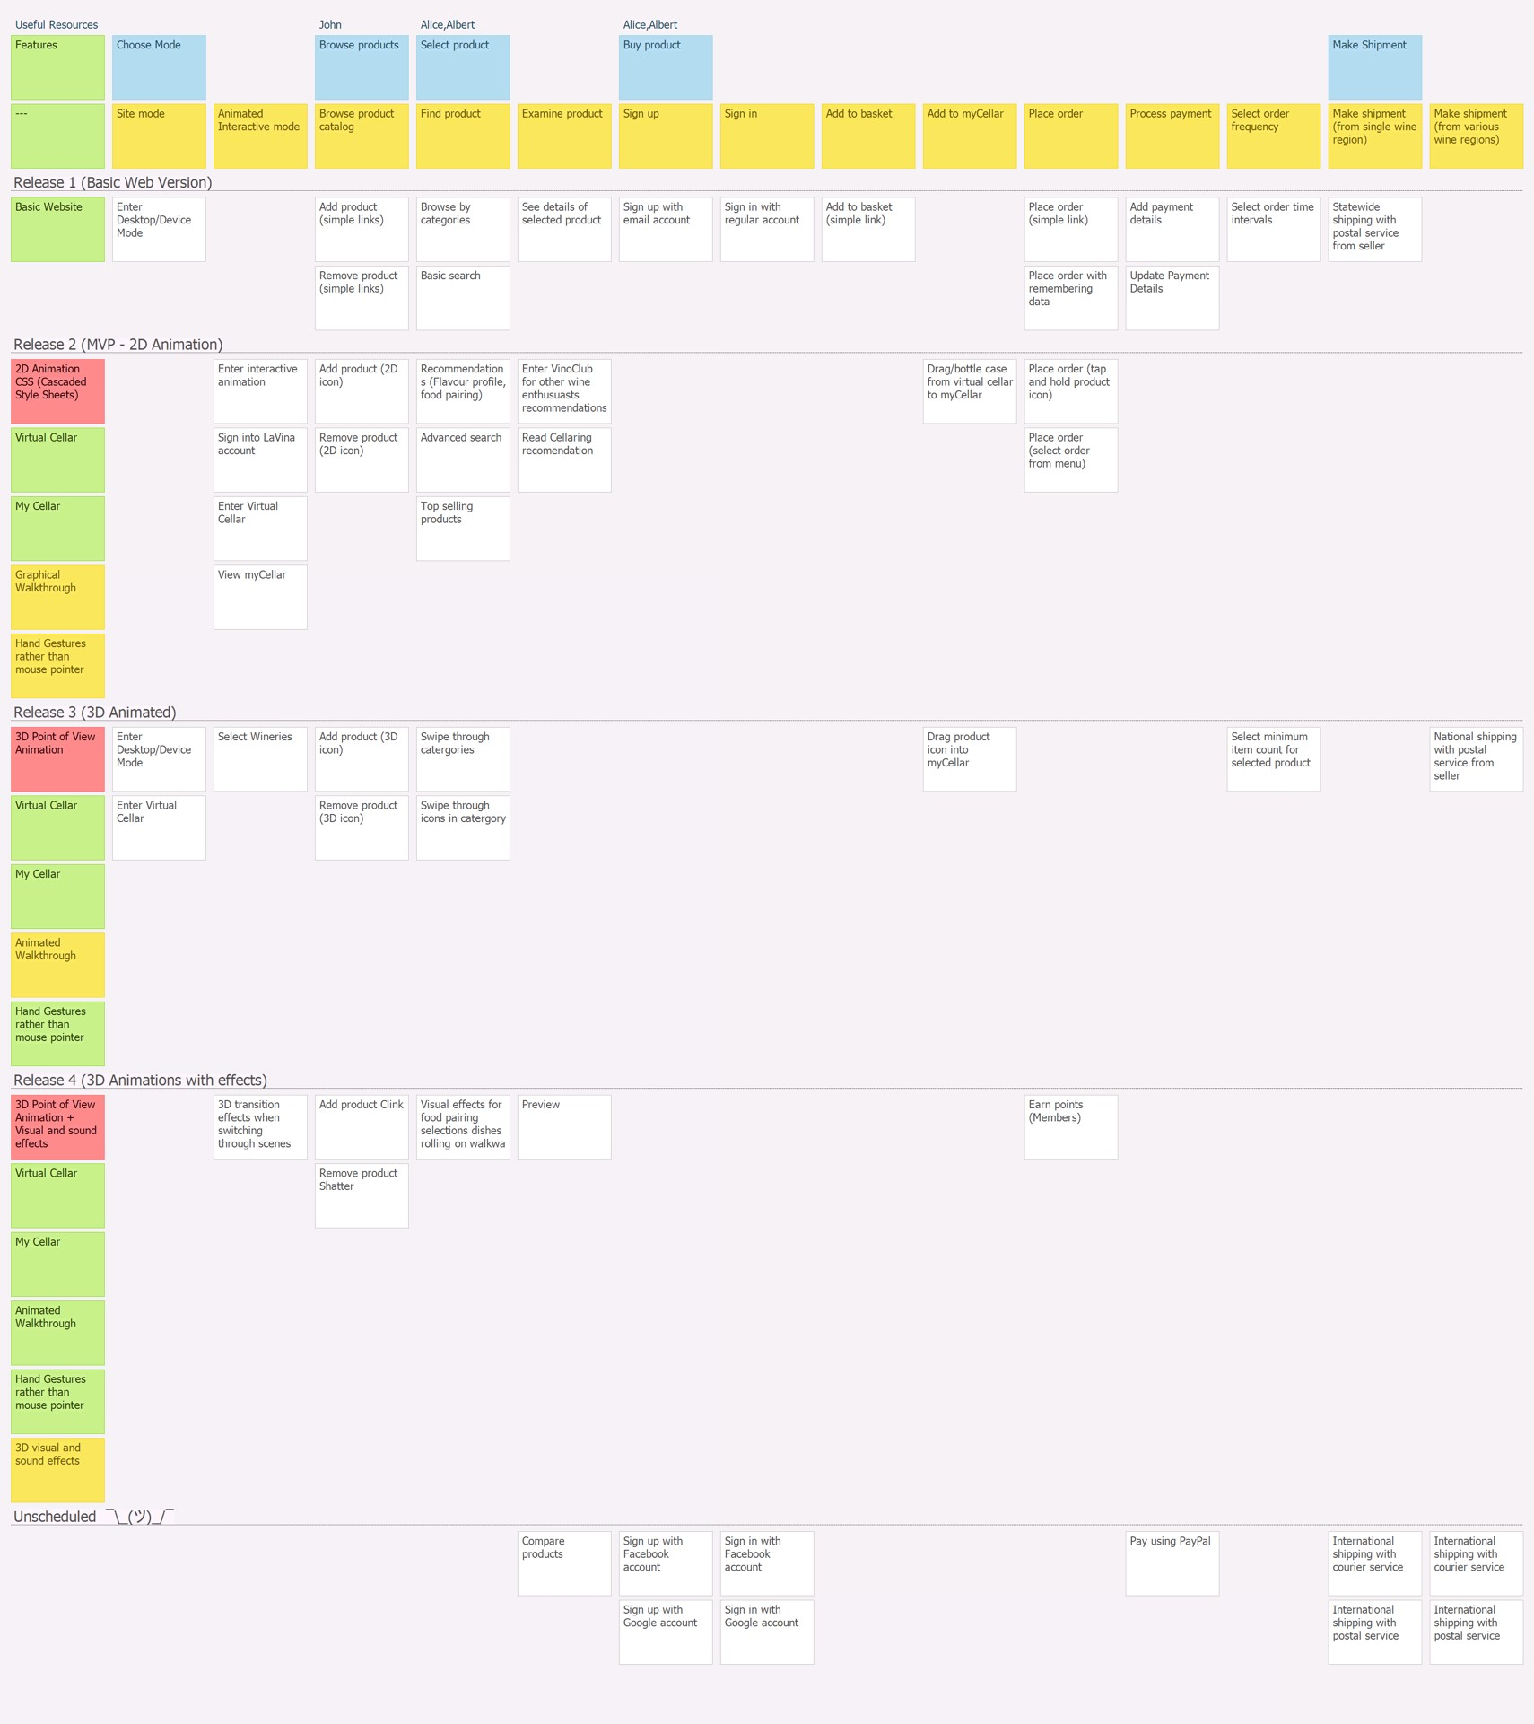

**Figure 10 Story Map showing the context of the La**◆**Viña system**

## Releasable Product

*Define your minimum requirements for a releasable product for this project.*

The minimum requirements for this product have been highlighted in table 3 above in section 4.1.

The first releasable product for La◆Viña is expected to be the second release shown in the story map (figure 10). At this stage the animation is three dimensional in the perspective of an areal view, using cascaded style sheets. The name La◆Viña will be used on the third and upcoming releases of the system, this is when the end user based requirements are coupled with high quality animation. The progress of these development stages is based on the rationale in section 2.2.

The quality of the image rendering for the virtual cellars in the second stage and the following stages have been illustrated using an example of a screenshot from a video game from 1998 on the left and the same video game released in 2004 on the right.

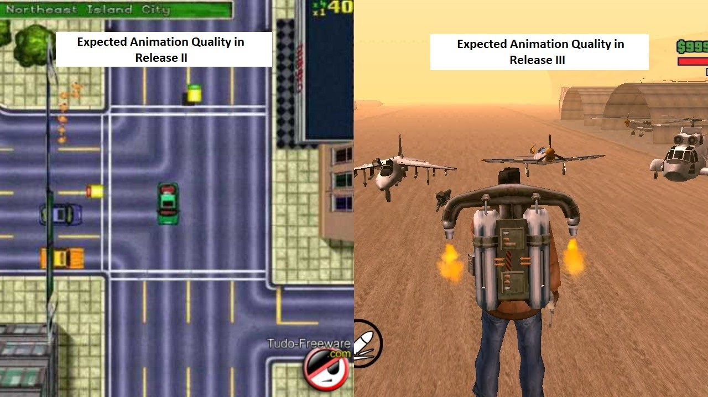

**Figure 11 Illustration of the expected quality of the products in the second release (left) and the rest of the releases (right)**

# Team

*Describe your team processes for this managing the team and the project and define your process for participatory decision making. This needs to be specific to the scenario and your team’s vision.*

Teamwork will be at the center of this project as the development approach will be done using the scrum flavor of the agile approach. The scrum approach is ideal as it relies on self-organizing crossfunctional teams where design decisions are made by the team as a whole rather than a single person. This means scrum development can essentially yield the best development solution as the design decisions are not based on a predefined process but rather incremental development and continuous feedback.

The scrum approach is the optimum design approach as it provides a structure for organising feedback, short term planning, stack ranking and inspect and adapt mindset as well as other organisational improvements. Thus agile development is about providing functionality with a shorter time to market compared to traditional project management, as the focus is on developing the product right with feedback after each iteration rather than focus on a predefined procedure.

At the end of every sprint the developed product increments will be reviewed with the client. The review session of each sprint output will be conducted with a group called the ViñoPanel, the viño panel will be an important part of the review of shippable increments as it is a review team with a range of participant from ordinary customers to subject matter experts on wine.

The ViñoPanel will be a group of eight people who have no technical backgrounds in software development, they will be in four groups of two people, they will be grouped as follows:

* Newbies, two people with a little general understanding of wine (2 people)
* Representatives from the client organization (2 people)
* Wine enthusiasts (2 people)
* Wine connoisseur, person who are domain subject matter experts in winery (2 people)

Before the end of each sprint the development team will conduct a technical analysis on the product, testing for quality involves ruthless testing unit testing and integration testing. Unit testing is the testing of each components of a sprint, integrations testing is testing that all units developed in various sprints work together. These test should be conducted among the development team before review sessions with the viñopanel, testers should be done by another team member, rotation of shifts is encouraged to promote insight, creativity and objectivity.

After the team has completed their technical analysis the product will be presented to the viñopanel. A review session with the viñopanel will allow the product to be assessed objectively, the facilitator of the review session ensures that particular users do not try to sway the opinion of other members. After reviewing the product the development team will use an interactive collaborative game called fishbowl where the development team observes and document while the viñopanel members speak of their user experience with the product.

The viñopanel members are then encouraged to collaborate with the development team members in an affinity map diagram activity to sort out technical and user interface elements of the product increment, this can include organization of elements in the virtual cellar as well as optimizing their interactive options with the end users’ myCellar feature. While the viñopanel members engage in card sorting activities the development team can ask questions but not provide any suggestions at all.

The performing organization will do its best to pick a team with various talents and developers with multiple talents to promote task switching or collaboration of multiple developers in the event of a bottleneck of development tasks in a lane of the Kanban tool.

The development team will be formed based on two criteria, the first is subject matter expertise and the second is their interest in the context of the design application. Team members will be selected from the performing organization based on their expertise and then selected by their level of enthusiasm of the concept of the proposed project.

The reason for this selection criteria is based on Daniel H. Pinks insight on motivation on task that require rudimental cognitive efforts. He states that people perform worse when monetary incentives are placed as a reward for work progress, this idea worked for physical labor in the early days of the industrial revolution. However in the information worker age, researches noticed that motivation boils down to three things; autonomy, mastery and purpose. In a TED talk he gave an example of a practice that is used in an Australian software company called Atlassian where “once a quarter on a Thursday afternoon the company tells their developers once a quarter to work on what ever they want for twenty four hours with whoever they want, but they must show the results at the end of the twenty-four hours, this is organized in a fun kind of meeting (with beer and cake) that is not a star chamber session, it had turned out that in that one day of pure undiluted autonomy has led to a whole array of fixes for existing software, a whole array of ideas for new products that otherwise had never emerged”, this is only in one day. The same is true for the development of Linux that powers one out of four corporate servers and fortune 500 companies, Apache which powers more than the majority of web servers and Wikipedia were all developed in the limited discretionary time of highly skilled workers. The motive behind such accomplishments turns out to be challenge and mastery along with making a contribution.This concept of motivation has been borrowed from the book *Drive* authored by Daniel H. Pink.

The development team for this application must have the same or somewhat similar organizational culture, while placing emphasis on accountability as to whom is developing what for each sprint. The activities in each sprint will be placed in the Kanban on a screen in the middle of the development teams meeting room where all members can see the team progress.

Each sprint will begin with a sprint planning session, in the first sprint the team will have a physical planning box where a member is to write a feature of the intended product onto that box and pass it to the next member until the box comes back to the first person, that box is to include the product vision and be kept in the middle of the table in the common meeting room.

The development method for each sprint before reviewing with the customer is as follows. A user story or several related user stories are selected from the backlog each user story is analyzed in a planning workshop session, using planning poker, once a consensus is reached the a story card is to be created for the user story. The analyzed story can then be put back into the backlog in its prioritized position or into the sprint backlog.

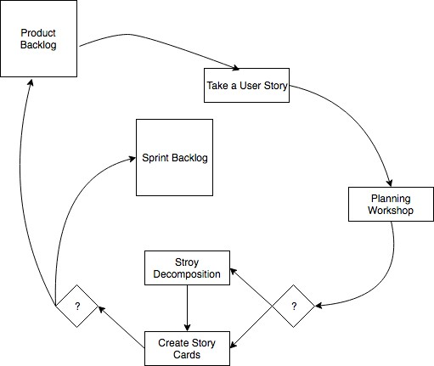

Planning poker is an ideal tool for decision-making as it promotes teamwork and development of a common goal of the task that need to be completed. As planning poker involves members turning over their cards at the same time, this is an approach that values the team member opinions and hence promotes team cohesion. The planning poker game should start with a user story that everybody in the team agrees on, the story point of the starting user story should ideally have a low story point in the Fibonacci sequence. The upside of using this method is to identify team members that are major outliers with their selection of poker cards, repeated cases of not team members not having the same score cards and hence not reaching consensus means one of two possibilities, that is: o Product uncertainty, or o Technical uncertainty

During the estimation sessions in planning workshops a team member may be randomly selected using a random pick generator, (this can even be done using http://pickatrandom.com/) where a team members goal is to be the *devil’s advocate*, whose role is to be a harsh critic (in an non confronting manner) to estimates and design solutions, this role could be necessary to promote realism as unnecessary risks may be taken in group collaboration settings.

Once a completed product iteration is reviewed by the ViñoPanel the observations and feedback are recorded. This new information then can be used as a retrospective for the next iteration. The focus of the team should be to reduce technical debt as early as possible, code refactoring and troubleshooting in early stages is better than dealing with technical debt at a later stage.

Team members need to take the retrospectives as an opportunity to assess the development progress and the performance of the team from the lessons learned to fulfil the project vision, as well as to assess the teams agile velocity. The vision statement is only fulfilled when both user requirements and technical requirements have been met.

For each product review the team has with the ViñoPanel, the project team should document the findings in a review document.

|  |  |  |  |  |  |  |
| --- | --- | --- | --- | --- | --- | --- |
|  | | Iteration/Sprint Review | | | | |
| Sprint: |  |  | | Phase: |  | |
| Meeting Members | | Development Team Members | | | |  |
| ViñoPanel Members | | | | < Usually all 8 members> |
| Topic/Issue: | |  | | | | |
| VinoPanel Member Name | |  | Feedback | | | |
|  | |  |  | | | |
|  | |  |  | | | |
|  | |  |  | | | |
|  | |  |  | | | |
|  | |  |  | | | |
| Result: | |  |  | | | |

The reviews need to be evaluated on a planning workshop where the facilitator starts the discussion by passing the product box (or vision box) to the first person immediately to their right, each person states their opinion or concerns before passing the product box to the next person until the product box returns to the facilitator.

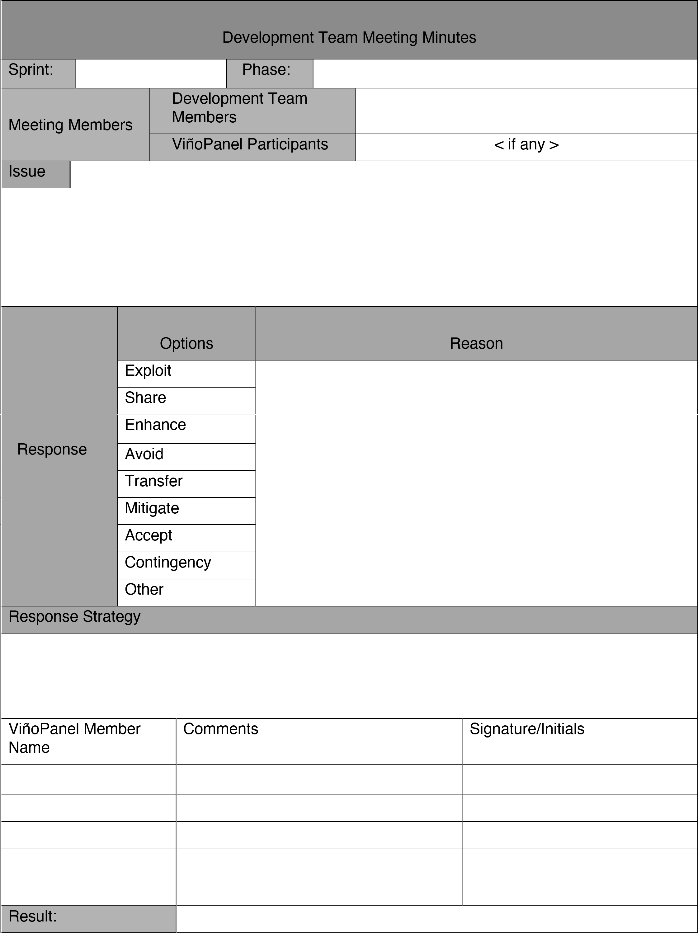

After the project is successfully completed all project documents and reports are signed off, transactions for invoices are completed. This is when the team has a compilation of reviews and retrospectives that can be referred to for estimation purposes in the upcoming projects.

At the end of the project, emails are sent that confirm successful delivery to the client. The release of

the product is tweeted on twitter, announced on the Facebook page of the developers. The development team touch in and celebrate by crack opening a chardonnay with the ViñoPanel members and the project owner.

# Review

*This section is written about* **your work as an individual throughout the course** *(not your work in this assessment, or your proposed scenario). Complete a performance evaluation, based on your*

*work across the full trimester. This should be consistent with a formal Agile Review and Retrospective process. Be honest and use critical reflection.*

This section covers my personal reflection (in first person point of view structure) as a review and retrospective of my performance over the trimester. This section will treat the work activities for my studies as the subject of analysis and in effect treating these activities in place of an agile project.

The first lessons learnt over the duration of this course is to analyze tasks activities and assessment and break them down into smaller elements or components, that is for example categorizing a proposed case scenario presented into smaller parts to organize presentation of the solution that has been ideated.

The components of the identified solution are then to be examined with the appropriate agile tool, which is available in the BABOK. For example to convince the relevance of a technical solution agile tools such as visioning to outline the purpose or purpose alignment model to identify the need for the proposed solution or wireframes and storyboards to capture the context of the desired product.

The next identified phenomenon that has been consistent through out the activities in this course has been the usage agile tools to support ideas in other tools. An example of this case is the use of story decompositions to break down the ideas into user stories, job stories, or story elaborations before feeding this information into story maps. This is an example of a general scenario not a concrete rule, an experienced analyst with real technical background may be able to generate a great deal of user stories using a story map as a starting point, this is only possible due to experience and the versatility of software tools as opposed to continually writing, erasing and rewriting.

An important technique that I have had to repeatedly use for different scenarios is refining backlogs through story decomposition until a well prioritized backlog has been created that is fit to have user stories transferred into the sprint backlog.

Over the course of studies the realization of the versatility of agile tools has occurred personally. The usability of reviews and retrospectives for supporting successful delivery as well as ensuring learning is one example of this case. Another example of such versatility is the ability to use agile tools side by side such as story cards and behavior driven development being used for test cases in later stages of development.

The new concepts learnt in this course from a personal standpoint include useful tools such as story cards that convey requirements from the users perspective while providing technical estimates from the development team. The fact that planning workshops activities such as planning poker can be used to develop such estimates is also a testament to the statement above about agile tools supporting the use of other agile tools.

Another concept learnt from this course, although this is stating an obvious fact, it is the importance of planning poker to ensure that the team does not bite more than it can chew, as well as developing teamwork to maintain a steady team velocity.

An important take away (or lessons learned) from this course is the importance of revisiting assessment items to improve the quality of work, the example of a user story below is an example of a meaningless statement in a requirements backlog:

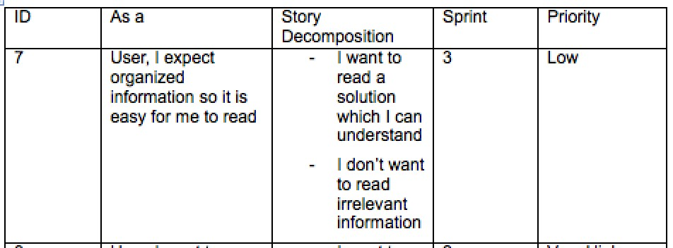

This leads to the topic of delivering concise work, the duration of this course has taught myself delivering quality lightweight work that is not cluttered with content and yet meaningful and applicable. As an example of this, this assessment piece could have included the five rules of cellaring wine, as it would definitely add content but it would not serve to demonstrate application of agile business concepts.

An intellectual spin-off of this course has been making the distinction between, knowing, understanding, and realizing concepts, this has been addressed through lectures, workshops and assessments. However these three levels of learning can only be best accomplished via attendance to all the mentioned sessions. The understanding and realizing components can be further attained through real life industry experience much like how user stories make most sense on mockups such as wireframes and storyboards and even further insight is gathered with prototypes.

The skill that this course forces to develop is managing the two mindsets, these I refer to as the “ *Coder’s mindset* ” and the “ *Business* ” mindset. The Coders Mindset is the traditional software development frame of mind that is focused on making logical deductions on how requirements can be fulfilled in the best possible way. The Business Mindset focuses on generating an effective solution on how to fulfill a business need, which can be delivered on time and provide value to the client organization.

The management of both mindsets compels students to strengthen or develop their capacity of ideation while managing an undertone insight into the technical aspect of the proposed solutions in order to deliver a realistic solution, which is crucial in the envision and speculate phase (of the Agile Project Management Framework) to propose a realistic idea to address a business need. The outcome of successful completion of this cause emphasizes on analyzing the feasibility of a proposal from business view, followed by the software engineering concept of “ *are we building the right product* ” and “ *are we building the product right* “.

In conclusion the learning objectives of this course can be summarized by emphasis on early planning, continual communication and collaboration, developing releases in smaller iterations to deliver quality shippable products and avoid unnecessary workload in the process, and avoid budget overruns, schedule delays as well as technical debts.